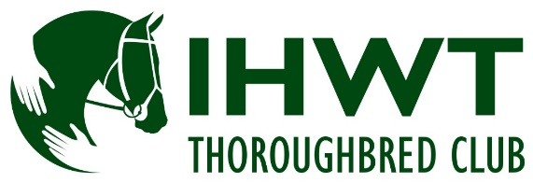

SHOW SERIES FOR RETIRED RACEHORSES 2016

Saturday 4th June Tattersalls International Horse Trials, Ratoath, Co Meath
Sunday 12th June AIRC National Festival, Stradbally, Co Laois
Sunday 10th July Wexford Equestrian Hunter Show, Ballygullick,
Co Wexford
Saturday 16th July Castlewellan Show, Castlewellan Forest Park, Co Down
Thursday 28th July Dungarvan Show, Co Waterford

The top 3 placings at each show will qualify for the
Final at Tullow Agricultural Show on 21st August.
Champion and Reserve at the Final qualify for the
RoR Championship Show at Aintree on 27th & 28th August.

Prizes with TRI vouchers and Rosettes 1st to 4th
1st €75 + Jacket, 2nd €50, 3rd €30, 4th €20)
plus veteran horse prize (15+) €25 voucher to be redeemed from the IHWT Office

Further details on Show locations on show websites or www.ihwt.ie

Show class is open to a Thoroughbred mare or gelding, 4 years old or over, any height. Riders must be 16 years or over by Jan 1st in current year. Horses should be ridden in a snaffle, pelham or simple double bridle. Horses should be plaited.
All competitors and horses MUST have registered in advance with The IHWT Thoroughbred Club (registration is free at www.ihwt.ie) and include their registration number on show entry form. Horses must be retired and have RACED in a point to point or on the racetrack. All those entering horses and/or participating in the show agree to be bound by the show Rules and Regulations from time to time in force’
Competitors must wear a safety/kite mark hard hat with a chinstrap.

The organisers reserve the right to amend or to cancel show classes without prior notice. It is advised that competitors check that shows are going ahead in advance of travelling.
Enquiries re eligibility and TB Club please email: events@ihwt.ie

